Casdoor 安装

- 下载casdoor
wget https://ssy-ops.oss-cn-shenzhen.aliyuncs.com/packages/casdoor_deploy-master.zip
- 启动
# unzip casdoor_deploy-master.zip
# vim casdoor_deploy-master/casdoor/conf/app.conf
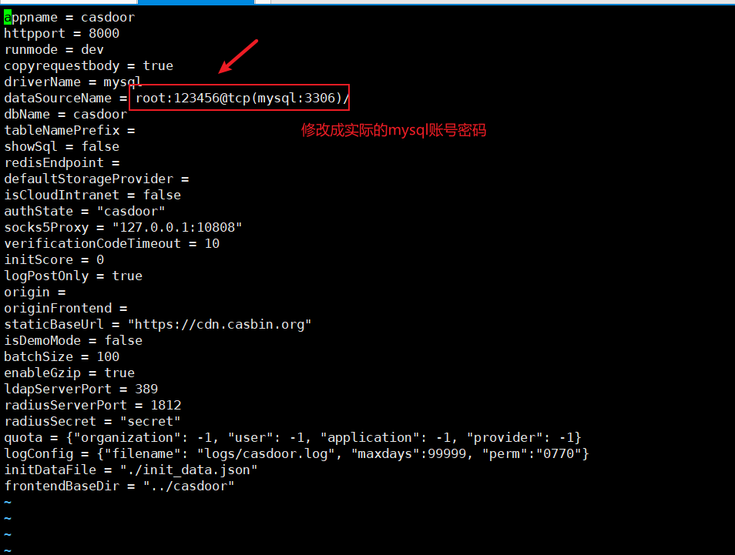
# vim casdoor_deploy-master/casdoor/docker-compose.yaml
